**Central Processing Unit**

A Central Processing Unit is the most important component of a [computer system](https://www.geeksforgeeks.org/basics-of-computer-and-its-operations). A CPU is hardware that performs data input/output, processing, and storage functions for a computer system. A CPU can be installed into a CPU socket. These sockets are generally located on the [motherboard](https://www.geeksforgeeks.org/what-is-motherboard/). CPU can perform various data processing operations. CPU can store data, instructions, programs, and intermediate results.

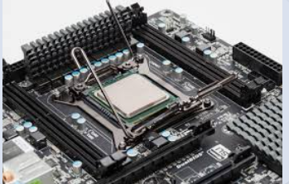

* **Hard Disk Drive (HDD) Secondary memory**

# Primary memory has limited storage capacity and it is volatile. Secondary memory overcomes this limitation by providing permanent storage of data in bulk quantity. Secondary memory is also termed external memory and refers to the various storage media on which a computer can store data and programs. The Secondary storage media can be fixed or removable. Fixed Storage media is an internal storage medium like a hard disk that is fixed inside the computer.

